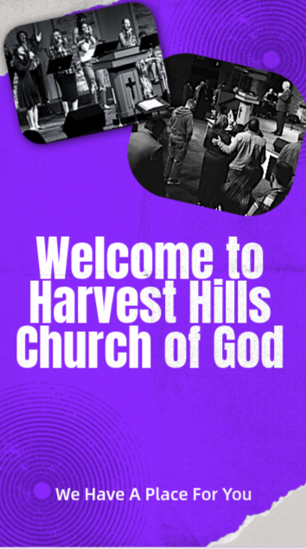
Harvest Happenings
October 18, 2026
2026 Ministry Theme: In His Presence
Let the godly rejoice. Let them be glad in God’s presence. Let them be filled with joy. Sing praises to God…Sing loud praises... His name is the Lord—rejoice in his presence! (Ps 68:3-4, NLT)

Holy Communion: Sunday, Nov 1st, during the morning worship service.
Men’s Ministry Breakfast: Saturday, Nov 14th, 8:30 a.m. in the gym. Volunteers are needed to cook. Sign-up sheet is on the information wall in the foyer. Questions? See Jim Henry
Family Focus Sunday: Sunday, Nov 15th, will be our quarterly Family Focus worship service, where our children will worship in the sanctuary with their families. Biblically themed packets will be available for Catalyst Kids aged children. Nursery will also be provided.
Women’s Ministries/Harvest Gold Holiday Social: Saturday, Nov 21st, 5:00 p.m., Church Gym. Guest appearance by Directors Trio. Cost is $10 per person. Sign-up sheet is located on the information wall. Questions? See Linda Jordan.
Journey to Bethlehem: SAVE THE DATE! Saturday, Dec 5th. Join us as we witness the wonder, hope, and love surrounding that holy night as we celebrate the greatest gift ever given, Jesus Christ. The sign-up sheet is on the information wall. Please sign up by Oct. 31st.
Pre-Service Prayer
Each Sunday, 10:00 AM, Church Library

War Room Prayer Service
Each Sunday, 6:00 PM to 7:00 PM

Fall: A Season of God’s Faithfulness
“To everything there is a season, and a time to every purpose under the heaven.” — Ecclesiastes 3:1 (KJV)
As the leaves turn brilliant shades of red, orange, and gold, fall reminds us of the beauty of God’s creation and the changing seasons of life. Each falling leaf carries a gentle reminder that God has a purpose for every season we experience.
A Season to Let Go - Just as trees release their leaves, we sometimes need to let go of the things that weigh us down—past hurts, worries, disappointments, and fears. God invites us to trust Him with our burdens and make room for His peace. Letting go is not a sign of weakness; it is an act of faith that allows us to move forward in His grace.
A Season to Harvest - Fall is a time of harvest, when the fruit of months of labor is gathered. Galatians 6:9 reminds us not to grow weary in doing good, for in due season we will reap if we do not give up. Every prayer, act of kindness, and seed of faith we plant can produce a harvest in God's time. Even when we cannot see the results, we can trust that our faithfulness matters.
A Season to Trust - As nature changes, one thing remains constant: God's faithfulness. Hebrews 13:8 declares, “Jesus Christ the same yesterday, and today, and forever.” Our circumstances may change, but our Savior never does. When life feels uncertain, we can remain rooted in Christ, trusting that He will guide us through every season.
A Season to Give Thanks - Fall also reminds us to count our blessings. Psalm 107:1 says, “O give thanks unto the LORD, for he is good: for his mercy endureth forever.” Gratitude helps us recognize God's goodness, even when life is not perfect. We can thank Him for His provision, His protection, His grace, and the promise of His presence each day.
As you enjoy the beauty of autumn, remember this: Leaves may fall, seasons may change, and life may bring unexpected challenges, but God's promises never fail. Whatever season you are facing, stay rooted in Christ, trust His timing, and give thanks for His unfailing love.
Mission Statement
Harvest Hills Church of God is a life situation, worship centered, Spirit-filled congregation committed to Exalting Christ, Equipping believers and Expanding the kingdom.

Today’s Sermon
Title:

Scripture:

Main Ideas:

I.

II.

III.

IV.

How can I apply today’s sermon in my daily life?



Russell A. Morris, PhD, Lead Pastor
3110 South Maple Avenue
Burlington, NC 27215
(336) 227-4441 (Office)
hhc@triad.twcbc.com
www.harvesthills.com

Food Pantry Ministry: Inflation, government shutdown, family crisis; no matter what situation comes our way, God is with us through them all. Thank you for your faithfulness and for remembering the food pantry ministry with your prayers and donations. If you know someone who needs food, please call Bill or Pat Brown at 336-222-9034

October Birthdays
Anna Turner 10/2
Lanie Graham 10/6
Dana Auton 10/17
Teresa Shockley 10/20
Cyndee Naber 10/24
Trevor Henderson 10/25
Abby Martin 10/29
Page Williamson 10/29

LIFE Sessions: Join us each Wednesday at 7:00 p.m. for an in-depth study of the Bible. Handouts available each session. Kids/Teens classes are also available.

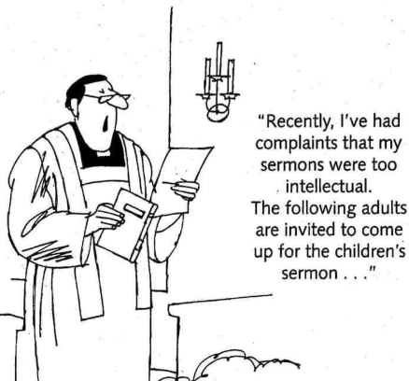
Rooted Young Adults Bible Study: Join us for a small group Bible study for high school grads - 30s. First & Third Wednesdays at 7:00 p.m. See Angela Williamson or Matt Auton for more information.

e-Prayer: If you would like to be a part of the e-Prayer team and receive prayer request and praise report notifications, please contact Dale Lowe. Send all prayer concerns to Dale Lowe, e-Prayer coordinator at hhcogeprayer@gmail.com. The prayer concerns will then be forwarded to the e-Prayer team. When prayer concerns are received, please read and pray over each one.

Allied Churches: Please continue bringing supplies to donate to Allied Churches. Currently, they need paper products (paper towels, toilet tissue, Kleenex, napkins, etc.), toothpaste, and cleaning products (Pine-Sol, spray cleaners, etc.). Place your donations next to the table in the foyer.


